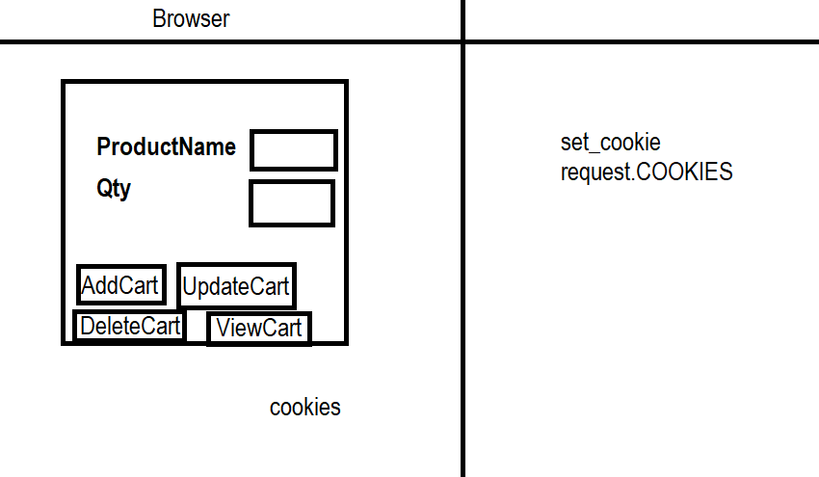

product_temp.html
<!DOCTYPE html>
<html lang="en">
<head>
<meta charset="UTF-8">
<meta name="viewport" content="width=device-width, initial-scale=1.0">
<title>Document</title>
</head>
<body>
<form action="/product">
<table border="2" width="100%">
<tr>
<td>ProductName</td>
<td><input type=text name="pname"></td>
</tr>
<tr>
<td>ProductQty</td>
<td><input type=text name="qty"></td>
</tr>
<tr>
<td><input type="submit" name="b" value="Add to Cart"></td>
<td><input type="submit" name="b" value="Update to Cart"></td>
</tr>
<tr>
<td><input type="submit" name="b" value="Delete from Cart"></td>
<td><input type="submit" name="b" value="View Cart"></td>
</tr>
</table>
</form>
<br><br><br>
<table width="100%" border="2">
{%for p in products%}
<tr>
<td>{{p.0}}</td>
<td>{{p.1}}</td>
</tr>
{%endfor%}
</table>
<h2>{{msg}}</h2>
</body>
</html>

Urls.py
from django.contrib import admin
from django.urls import path
from app.views import product_view

urlpatterns = [
path('admin/', admin.site.urls),
path('product/',product_view),
]

Views.py
from django.shortcuts import render

# Create your views here.
def product_view(request):
pname=request.GET.get('pname')
qty=request.GET.get('qty')
b=request.GET.get("b")
print(b)
if b=="Add to Cart":
response=render(request,"products_temp.html",context={'msg':'Product Added'})
response.set_cookie(pname,qty)
return response
elif b=="Update to Cart":
if pname in request.COOKIES:
response=render(request,"products_temp.html",context={'msg':'Product Updated'})
response.set_cookie(pname,qty)
return response
else:
response=render(request,"products_temp.html",context={'msg':'Product not exists'})
return response
elif b=="Delete from Cart":
if pname in request.COOKIES:
response=render(request,"products_temp.html",context={'msg':'Product Deleted'})
response.delete_cookie(pname)
return response
else:
response=render(request,"products_temp.html",context={'msg':'Product not exists'})
return response
else:
products=[]
for p in request.COOKIES.items():
if p[0]!='csrftoken':
products.append(p)
response=render(request,"products_temp.html",context={'products':products})
return response

settings.py
INSTALLED_APPS = [
'django.contrib.admin',
'django.contrib.auth',
'django.contrib.contenttypes',
'django.contrib.sessions',
'django.contrib.messages',
'django.contrib.staticfiles',
'app'
]

TEMPLATES = [
{
'BACKEND': 'django.template.backends.django.DjangoTemplates',
'DIRS': [BASE_DIR/"templates"],
'APP_DIRS': True,

Persistent Cookies
Persistent cookies exists within browsers database even after browser is closed.
How to create persistent cookie?
- set_cookie(name,value,max_age=seconds)
- set_cookie(name,value,expires=datetimeobject)

default cookies are non persistent cookies, these cookies are get deleted automatically once browser is closed. Default max_age is None.

Views.py
Example of max_age keyword argument or attribute
from django.shortcuts import render

# Create your views here.
def product_view(request):
pname=request.GET.get('pname')
qty=request.GET.get('qty')
b=request.GET.get("b")
print(b)
if b=="Add to Cart":
response=render(request,"products_temp.html",context={'msg':'Product Added'})
response.set_cookie(pname,qty,max_age=300)
return response
elif b=="Update to Cart":
if pname in request.COOKIES:
response=render(request,"products_temp.html",context={'msg':'Product Updated'})
response.set_cookie(pname,qty,max_age=300)
return response
else:
response=render(request,"products_temp.html",context={'msg':'Product not exists'})
return response
elif b=="Delete from Cart":
if pname in request.COOKIES:
response=render(request,"products_temp.html",context={'msg':'Product Deleted'})
response.delete_cookie(pname)
return response
else:
response=render(request,"products_temp.html",context={'msg':'Product not exists'})
return response
else:
products=[]
for p in request.COOKIES.items():
if p[0]!='csrftoken':
products.append(p)
response=render(request,"products_temp.html",context={'products':products})
return response

views.py
Example of expires using datetime object

from django.shortcuts import render
from datetime import datetime
# Create your views here.
def product_view(request):
dt=datetime(2026,5,2,10,40,50)
pname=request.GET.get('pname')
qty=request.GET.get('qty')
b=request.GET.get("b")
print(b)
if b=="Add to Cart":
response=render(request,"products_temp.html",context={'msg':'Product Added'})
response.set_cookie(pname,qty,expires=dt)
return response
elif b=="Update to Cart":
if pname in request.COOKIES:
response=render(request,"products_temp.html",context={'msg':'Product Updated'})
response.set_cookie(pname,qty,expires=dt)
return response
else:
response=render(request,"products_temp.html",context={'msg':'Product not exists'})
return response
elif b=="Delete from Cart":
if pname in request.COOKIES:
response=render(request,"products_temp.html",context={'msg':'Product Deleted'})
response.delete_cookie(pname)
return response
else:
response=render(request,"products_temp.html",context={'msg':'Product not exists'})
return response
else:
products=[]
for p in request.COOKIES.items():
if p[0]!='csrftoken':
products.append(p)
response=render(request,"products_temp.html",context={'products':products})
return response

